School Readiness Checklist

The Buckinghamshire Healthcare NHS Trust Integrated Public Health Nursing Team for children and young people 0-19 years (24 years for SEND) are keen to support you and your child get ready for school.
To start a chat with the Health Visitors, send a message to
07312 277363

What is the aim of this checklist?
We hope this checklist will help you prepare your child for school when they start in Reception Class. It is focused on your child’s overall health and emotional wellbeing at this important time in their life.

If you answer YES to any of these questions check out the links to further advice and support. Your Health Visiting Team has a parent chat text messaging service where you can ask your specific questions also. Don’t forget to discuss any concerns with schools they can be prepared and support your child’s transition too.

 |  | Yes | No
1 | Has your child received their pre-school vaccinations?  If no, or you are unsure, please contact your GP and see https://www.nhs.uk/vaccinations/
2 | Is your child registered with a dentist?  If NO, you can find a local dentist by accessing www.nhs.uk . This is a free service.
3 | Does your child have any other additional needs- including long-term health conditions such as severe food allergies, asthma, eczema or epilepsy?  If YES, have you informed the school?
4 | Does anyone in your household have a long-term health condition that may affect your child’s school attendance?  If YES, have you informed the school?
5 | Do you feel confident about keeping your child safe online?  If no, or you are unsure please see https://www.nspcc.org.uk/keeping-children-safe/online-safety/
6 | Is your child under the care of an optician/orthoptist/eye clinic and/or wears glasses?  You will be offered a vision screening for your child during the reception year. You can find out more on the link below.  https://www.gov.uk/government/publications/child-vision-screening-information-for-parents/child-vision-screening-information-for-parents

The next section is about your child’s development in relation to readiness for school
 |  | Yes | No
7 | Toileting - does your child experience any of the following:  - day time wetting  - night time wetting  - constipation  - soiling  If YES, the links below will offer further support:  https://www.healthforkids.co.uk/buckinghamshire/getting-ready-for-school-toileting-tips/  https://www.buckshealthcare.nhs.uk/cyp/health-visiting-webinars/  https://healthforunder5s.co.uk/sections/toddler/your-video-guide-to-toilet-training/  https://healthforunder5s.co.uk/buckinghamshire/local-advice-and-events/events/?cat=starting-toilet-training  https://eric.org.uk/potty-training/toilets-and-school-readiness/
8 | Do you have any concerns with your child’s growth or development? For example, can your child take turns and share when playing with others?  Children in Reception are offered a height and weight check as part of the National Childhood Measurement Programme. https://www.healthandwellbeingbucks.org/s4s/WhereILive/Council?pageId=5937  If YES, have you shared your concerns with the GP?  The links below will offer further support:  https://www.healthforkids.co.uk/buckinghamshire/school-readiness/  https://healthforunder5s.co.uk/sections/preschool/skills-for-starting-school/  https://bhb.maximusuk.co.uk/families-academy-sign-up/
9 | Is your child independent with getting dressed/ undressed/ washing hands/ using cutlery to eat food?  The links below will offer further support:  https://www.healthforkids.co.uk/buckinghamshire/school-readiness/
10 | Does your child have any difficulties with sleeping?  The links below will offer further support:  https://www.healthforkids.co.uk/buckinghamshire/school-readiness/  https://thesleepcharity.org.uk/information-support/children/relaxation-tips/

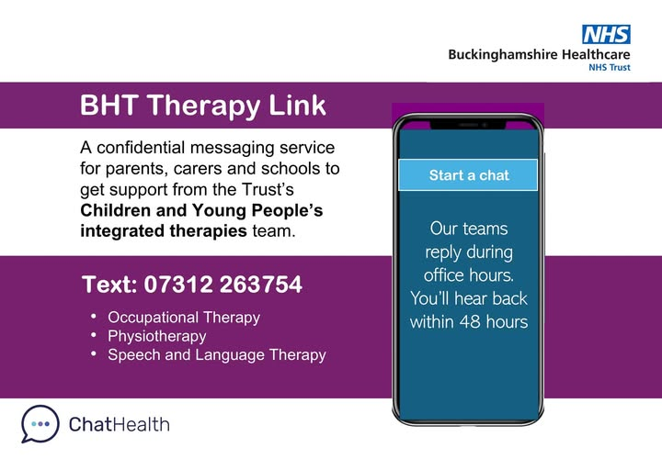 | 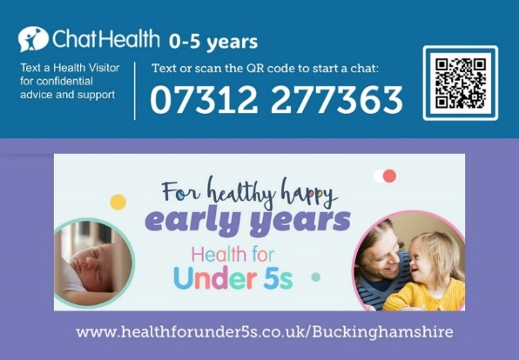
Bucks SENDIAS: Special Educational Needs and Disability Information and Advice Support Service - https://www.buckinghamshire.gov.uk/schools-and-learning/bucks-sendias-service/

Family Hub Network - https://familyinfo.buckinghamshire.gov.uk/family-hub-network/

Children and Young People’s Website -https://www.buckshealthcare.nhs.uk/cyp/

