Carrington Infant School SEND Information Report

September 2025

All Buckinghamshire Local Authority (LA) maintained schools are supported by the LA to ensure that all pupils, regardless of their specific needs, make the best possible progress in school. All schools are supported to be as inclusive as possible, with the needs of pupils with Special Educational Needs and Disabilities being met in a mainstream setting wherever possible. As laid out in the SEND Code of Practice January 2015, the four main ‘areas of need’ are:

- Communication and Interaction
- Cognition and Learning
- Social, Emotional and Mental Health Difficulties
- Sensory and Physical Needs

What is the Local Offer?
Local Authorities and schools are required by legislation to publish and review information about services they have available for children and young people with Special Educational Needs and/or Disabilities (SEND) aged 0 - 25. This is known as the ‘Local Offer’.

The Local Offer improves choice and transparency for families of children with SEND. It is an important resource for parents in understanding the range of services and provision in the local area. It is designed to be an active signposting tool. Buckinghamshire’s Local Offer can be found at www.bucksfamilyinfo.org under the tab at the top entitled ‘Local Offer’. The school’s Accessibility Plan can be found on our school website:

The Buckinghamshire County Council SEND Team support the school by allocating a designated Education and Health Plan Co-ordinator (ECCo) to liaise with the school regarding any pupil who has an Educational Health Care plan or is being assessed in order to see if they require and EHC plan.

The ECCo for Carrington Infant School is: Shannon Smyth
Email address:ssmyth@buckinghamshire.gov.uk

The telephone number for the SEND team at Buckinghamshire County Council is: 01296 382269 ( press 4) for the Wycombe Team.

If your child has Special Educational Needs and/or Disabilities, what can Carrington Infant School offer you?

At Carrington Infant School, we celebrate the fact that every child is different, and consequently the educational needs of every child are different. This is certainly the case for children with Special Educational Needs and Disabilities. Below are a set of questions and answers that we feel cover what Carrington Infant School offers in order to support children with SEND and their families.

1. Who are the best people to talk to at Carrington Infant School about my child’s difficulties with learning or SEND?

Talking to the teacher – open door policy
The initial point of contact to discuss any concern you may have with regards to your child’s learning will be with your child’s Class Teacher. In turn they will raise any issues with the Assistant Head for Inclusion and a meeting between all stakeholders (where appropriate) will take place to discuss possible support strategies that may need to be implemented.

Parent consultation appointments
We hold parent consultations twice a year to discuss the progress of the children. These meetings are an opportunity for parents to discuss what they feel is going well about their child’s education and to voice any concerns that they may have.

The Assistant Head for Inclusion at Carrington Infant School is: Mrs. Katie Buckley. She is available to meet with parents who have concerns regarding their child’s progress, throughout the year. Please feel free to contact the school office to make an appointment to see Mrs. Buckley with any concerns you may have relating to the SEND needs of your child.

2. How can I let the school know I am concerned about my child’s progress in school?

If you have concerns about your child’s progress, you should speak directly to your child’s Class Teacher initially.
If you continue to be concerned that your child is not making academic progress or has any other Special Educational Need and/or Disabilities, you can speak to the Assistant Head for Inclusion, Mrs. Katie Buckley. The Head Teacher, Mrs. Kate Cliffe. The SEND Governor can also be contacted for support.

3.
How will the school let me know they are concerned about my child’s learning in school?

If your child is identified as not making progress or having SEND, we will contact you to set up a meeting to discuss this in more detail. We will listen to any concerns you may have, plan any additional support your child may need and discuss with you any referrals to outside professionals that may be made in order to fully support your child. This meeting may be undertaken with or without child present, depending upon the appropriateness of the discussion.

4. How is extra support allocated to children and how do they progress in their learning?

The school budget, received from Buckinghamshire LA, includes money for supporting children with SEND. The Head teacher decides on the deployment of resources for Special Educational Needs and Disabilities, in consultation with the school governors on the basis of needs within the school. The Head Teacher and the Assistant Head for Inclusion discuss all the information they have about SEND in the school, including children already receiving extra support, children needing extra support and children who have been identified as not making as much progress as would be expected. From this information, they decide what resources/training and support is needed. The school identifies the needs of SEND pupils on a SEND profile. This, in turn, is put into an Intervention timetable. The intervention timetable identifies all support given within the school and is reviewed regularly and changes made as needed, so that the needs of children are met, and resources are deployed as effectively as possible. The intervention timetable details any interventions that a child may receive and how regularly they receive it. In addition to usual formative and summative assessments that take place, the impact of small group work or interventions is monitored.

The school follows an Assess, Plan, Do Review model for supporting SEND pupils. For example, if a child is receiving an intervention to support them with their spellings, they may complete a spelling test at the start of the intervention. This is recorded. The sessions then take place as detailed on the class Intervention Timetable over a period of 6-8 weeks. The same spelling test is then completed again and the result is recorded. This provides a clear picture of whether the spelling intervention sessions have had a positive impact as the two results can be compared. If the child has made considerable progress it will be reviewed as to whether they still require the intervention. If the child has an EHC Plan the targets from section E will be broken down into manageable steps on a Multi Agency Provision Plan. This identifies the specific steps towards meeting their long term outcomes from section E of the EHC plan and the interventions to enable the children to make progress towards achieving their long term outcomes.

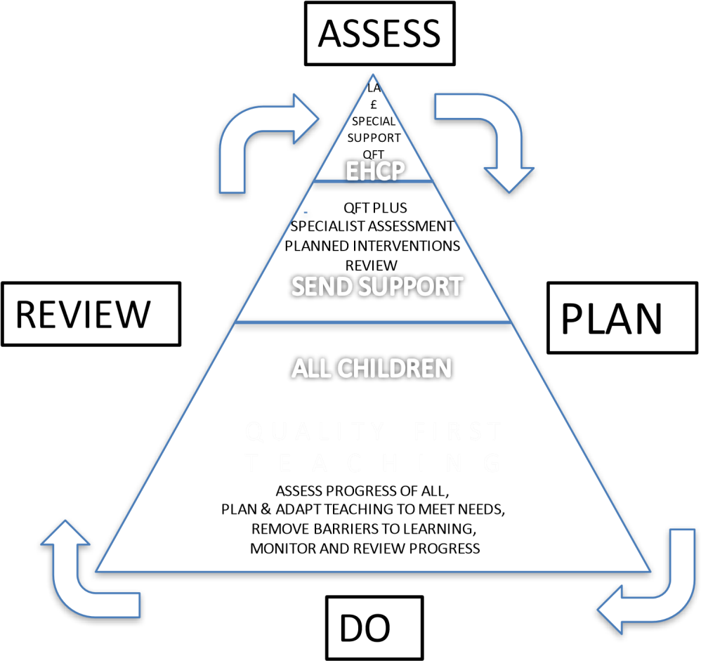

5. Who is responsible for SEND provision at Carrington Infant School?

We all are! As educators, we have a duty of care and responsibility to all our pupils.
Class Teacher
Your child’s Class Teacher is responsible for monitoring the progress of your child and identifying, planning and delivering any additional help your child may need (this could be targeted interventions or additional support) and letting the Assistant Head for Inclusion know, as necessary.

Your child’s Class Teacher is responsible for setting targets for your child and sharing and reviewing these with you as a parent. Your child’s class teacher will ensure your child receives personalised teaching and additional support as identified on the class Intervention Timetable.

Your child’s Class Teacher is also responsible for ensuring that the school’s Special Educational Needs and/or Disabilities Policy is followed in their classroom and during their lessons for all the pupils they teach.

Assistant Head: Inclusion: Mrs. Katie Buckley
The Assistant Head for Inclusion is responsible for developing and reviewing the school’s SEND policy in conjunction with stakeholders (parents, children with SEND, Head teacher, Governors, staff, Multi-Agency Partners). The Assistant Head for Inclusion is also responsible for overseeing and coordinating all the support for children with special educational needs or disabilities (SEND). She also ensures that you as parents are involved in supporting your child’s learning; kept informed about the support your child is getting and involved in reviewing how they are doing. She is also responsible for liaising with the other people who may be coming in to school to help support your child’s learning, e.g. Speech and Language Therapists, Educational Psychologists, and Occupational Therapists. She will ensure that you receive the necessary paperwork such as consent forms before professionals observe your child and reports after visits have taken place. The Assistant Head for Inclusion is responsible for updating the school’s SEND register (a system for ensuring that all the SEND needs of pupils in this school are known) and making sure that records of your child’s progress and needs are kept and maintained. She also provides specialist support for teachers and support staff in the school, so that they can help children with SEND in the school to achieve the best progress possible.

The Head teacher: Mrs. Kate Cliffe
The Head teacher is responsible for the day-to-day management of all aspects of the school; this includes the support for children with SEND. The Head teacher gives responsibility to the Assistant Head for Inclusion and Class Teachers, but still has overall responsibility for ensuring that your child’s needs are met. The Head Teacher ensures thatthe Governing Board is kept up to date about issues relating to SEND.

The SEND Governor
The SEND Governor is responsible for making sure that the necessary support is given for any child with SEND who attends the school. She works together with the Assistant Head for Inclusion and also provides a questioning role as to the SEND practices and procedures within the school to ensure best practice.
If you would like to contact the SEND Governor, please make an appointment through the school Office. School contact telephone number: 01628 523356
6. How do you as a school identify children with SEND?

If the Class Teacher is concerned about the progress of a child in relation to an area of SEND, she / he will undertake an Initial Concern conversation with the Assistant Head for Inclusion. This in turn triggers a class based observation of the child by the Assistant Head for Inclusion. The Assistant Head for Inclusion will then liaise with the Class Teacher to discuss the observation and the Initial Concern discussion and a decision will be made as to the next appropriate steps. The Assistant Head for Inclusion will keep a record of all Initial Concern discussions and outcomes. These will be shared with the Headteacher and SEND Governor.

At this stage the child is monitored closely to see if they require any additional support above and beyond that of the rest of the children. If additional support is required, a meeting is held with the parents and child (where appropriate) to discuss the possibility of being placed on the SEND register. Some diagnostic tests may be carried out. These assessments will be used to help identify which pupils may need targeted interventions and can also give extra information in terms of identifying progress made by pupils who may not reach Age Related Expectations (ARE).

7. What happens when it is deemed that my child needs more support and is placed on the SEND register?

SEND Code of Practice (2015): School Educational Need Support (SEN Support plan)
This means a pupil has been identified by the Assistant Head for Inclusion / class teacher as needing some extra specialist support in school from a professional outside the school. This may be from outside agencies, such as the Cognition and Learning team, Speech and Language Therapy (SALT) Service or Sensory Service (for pupils with a hearing or visual need).

What could happen?

You may be asked to give your permission for the school to refer your child to a specialist professional, e.g. a Speech and Language Therapist or Educational Psychologist. This will help the school and you to understand your child’s particular needs better and be able to support them more effectively in school. The specialist professional will work with your child to understand their needs and make recommendations as to the ways your child is given support.

Specified individual support

This type of support is available for children whose learning needs are severe, complex and lifelong. This is usually provided via an Education, Health and Care Plan (EHCP). This means your child will have been identified by professionals as needing a particularly high level of individual or small-group teaching. This type of support is available for children with specific barriers to learning that cannot be overcome through Quality First Teaching and intervention groups. Your child will also need specialist support in school from professionals both inside and outside the school. This may be from a range of outside agencies.

If you believe your child requires an EHC plan

You can request that Local Authority Services carry out a statutory assessment of your child’s needs. This is a legal process which sets out the amount of support that will be provided for your child. After the request has been made to the ‘Panel of Professionals’ (with a lot of information about your child, including some from you), they will decide whether they think your child’s needs (as described in the paperwork provided), seem complex enough to need a statutory assessment. If this is the case, they will ask you and all professionals involved with your child to write a report outlining your child’s needs. If they do not think your child needs this, they will ask the school to continue with the current support provided.

After the reports have all been sent in, the Panel of Professionals will decide if your child’s needs are severe, complex and lifelong. If this is the case, they will write an Education Health Care Plan (EHCP). If this is not the case, they will ask the school to continue with the current level of support. The EHC Plan will outline the number of hours of individual/small group support your child will receive from the LA and how the support should be used, and what strategies must be put in place. It will also have long- and short-term goals for your child. The additional adult may be used to support your child with whole class learning, run individual programmes or run small groups including your child.

7. What are the different types of support available at Carrington Infant School for children with SEND?

Initially the support available is via excellent targeted classroom teaching (Quality First Teaching). For your child this would mean that the teacher has the highest possible expectations for your child and all pupils in their class. The emphasis is that all teaching is built on what your child already knows, can do and can understand. Different ways of teaching are in place, so that your child is fully involved in learning in the classroom. This may involve things like using more practical learning and ensuring that specific strategies (which may be suggested by the Assistant Head for Inclusion) are in place to support your child to learn. Your child’s teacher will have carefully checked on your child’s progress and will have decided that your child has a gap or gaps in theirunderstanding/learning and needs some extra support to help them make the best possible progress.
Your child may then be the focus of specific group work as identified on the class Provision Map. This could include 1:1 reading, Phonics Catch-Up, Lego Therapy, OT Sensory Circuits, Speechlink, Languagelink, Maths Catch-Up. These interventions may be run in the classroom or a group room and may be run by a teacher or a learning support staff (LSS).
Alternatively, your child may be the focus of specialist groups or 1:1 sessions run by outside agencies, e.g. the Speech and Language Therapy team or the Occupational Therapy Team.
8. What is the ARP/Rainbow Class?
We are very lucky to have an ARP as part of our school provision. ARP stands for Additional Resourced Provision. This is a County provision for children on the Autism Spectrum. It is a six-place class, staff by three specialist support staff; one teacher and two specialist Teaching Assistants. Pupils are allocated a place in this resource by the County Panel application process. Every child within the ARP has his or her own EHC Plan.
The specialist staff within the ARP support the staff at Carrington Infant School with advice, resources and training.

9. What kind of equipment / facilities are there to support children with SEND?
Equipment and facilities are entirely dependent upon need. If your child has a physical need the Physical Disabilities team will come in and carry out an assessment. Any recommended alterations will be made e.g. sloped exits/entrances for wheelchair access, handles / rails or the team may assess ICT equipment for children with additional communication needs and recommend equipment to purchase e.g. communication boards. Other more general equipment may include support workbooks e.g. ‘Konnect Skills, through to board games to develop co-operation and negotiation skills for autistic children. We respond actively to any recommendations with regards to equipment made by specialist outside agencies and look to secure such equipment where funds allow us.

10. How do you involve me as a parent?

At Carrington Infant School we are keen to involve parents and carers as much as possible in their child’s education and welfare. We hold regular meetings and operate an open-door policy. If you wish to speak to the Class Teacher, Assistant Head for Inclusion or Head Teacher we are happy to arrange an appointment at a time convenient to you. We ensure all paperwork is up to date and copies of reports from outside agencies are sent home. We hold parents’ evenings twice a year, and the opportunity of an additional meeting with the Assistant Head for Inclusion. We also send out annual questionnaires to parents of children with SEND to gain feedback in order to adapt and improve our services to ensure they are the best we can provide. We also are keen to signpost parents and carers to other support agencies such as childcare for children with SEND, Short Breaks for Carers, Mental Health Services all which can be accessed through the Buckinghamshire Local Offer which can be found on www.bucksfamilyinfo.org under the tab at the top entitled ‘Local Offer’.

11. How do you involve my child?

At Carrington Infant School we are keen to involve children in their education as much as possible. We feel it is vital for children to have ownership of their own learning and as a result have an involvement in developing their own SEN Support Plan. We operate an open-door policy for children too and they have the freedom to speak to anyone they feel comfortable with, within the school. We have recently started termly SEND pupil focus groups to gain a more dynamic assessment of feedback.
12. What do I do if I am not happy with how things are going?

If you are not happy at any point, your first port of call is to speak to your child’s class teacher. If you feel it is not resolved then your next step is to speak to the Assistant Head for Inclusion.
Again, if you feel this still does not resolve the situation, you next step is to speak to the Head Teacher. If you are still not happy with the resolution offered, you will need to contact the SEND Governor.
13. Who are the other people providing services to children with SEND at Carrington Infant School?

There are many people who provide services to children with SEND at Carrington Infant School. We have strong, good working relationships with all our Multi-Agency Partners and are keen to develop new relationship where needs arise.

School provision:

- Teachers responsible for teaching SEND groups/individuals on a part-time basis
- Learning Support Staff (LSS) working with either individual children or small groups
- Support for children with emotional and social development
- Support for vulnerable children through in-house support from LSS and Teachers

Outside Agency Professional Provision currently delivered in school:
- Social, Emotional and Mental Health Outreach – Pupil Referral Team
- Family Support Service - pupil visits
- Mental Health Support Team
- Speech and Language
- Occupational Therapist

Health Provision delivered in school:

- Speech and Language Therapy
- School Nursing Team – online training available and consultation service available
- Children and Adolescent Mental Health (CAMHs) link-worker

14. How are teachers at Carrington Infant School helped to work with children with SEND and what training do they have?

The Assistant Head for Inclusion’s job is to support class teachers in planning for children with SEND. Carrington Infant School provides training and support to enable all staff to improve the teaching and learning of children, including those with SEND. This includes whole school training on areas of SEND such as Autism and speech and language difficulties. Individual teachers and support staff attend training courses run by outside agencies thatare relevant to the needs of specific children in their class, e.g. ‘Supporting Children with Dyslexic tendencies’.
There are regular staff meetings on SEND. Each class has a SEND file stored securely on the school intranet. LSS can access this information such as the child’s most recent EHCP or SEND Support Plan and any relevant background information which will enable the child to be fully supported.

15. How will the teaching be adapted for my child with SEND?

Our planning is differentiated to enable all learners to achieve the learning objective for each lesson. Planning and teaching is adapted on a daily basis, to meet your child’s learning needs. Differentiation can occur through: variation in questioning; a different activity where the outcome in terms of learning is still the same; a more practical approach or a change in support resources where learning is scaffolded more clearly. We are keen to ensure that children with SEND still need to be challenged so they can Sparkle and Shine. Learning Support Staff, under the direction of the class teacher, can adapt planning to support the needs of your child

where necessary. Specific resources and strategies will be used to support your child individually and in groups.

16. How will you measure the progress of my child with SEND at Carrington Infant School?
Your child’s progress will be continually monitored and reviewed by his/her class teacher. In addition, the Head teacher and Assistant Head for Inclusion will review the whole school pupil progress trends in terms of reading, writing and maths using target tracker and assessment data.

We aim to meet the needs of all learners. For those learners who are unable to access their relevant age -related curriculum and who are not yet ready to access the programme of study for their year, teachers will tailor the learning to suit the pupil’s needs. All pupils are expected to make good progress from their starting point each year. The current system of Age Related Expectations (ARE) is not inclusive for some children with SEND, who may, year on year still be assessed as ‘emerging’ as smaller progress steps are not recognised. This may potentially have a negative impact on some pupils with SEND whose progress is not recognised.
Consequently, we use the Engagement Model and Pre-Key Stage Standards document to inform judgements.

Regular book scrutinies and lesson observations are carried out by the Assistant Head for Inclusion and other members of the Senior Leadership Team to ensure that the needs of all children are met and that the quality of teaching and learning is high and that progress is being made. A home-school communication book may be used to support communication with you when this has been agreed to be useful for you and your child.

The class teacher is regularly available to discuss your child’s progress or any concerns you may have and to share information about what is working well at home and school, so that similar strategies can be used. The Assistant Head for Inclusion is available to meet with you to discuss your child’s progress or any concerns/worries you may have. All information from outside professionals will be discussed with you with the person involved directly, or where this is not possible, in a report.

The progress of children with an EHC Plan will be formally reviewed at an Annual Review. All adults involved with the child’s education are invited to this meeting. Your child’s views are taken into account and are discussed at the Annual Review.
17. How is Carrington Infant School accessible for children with SEND?

The school has an accessibility plan, should any child require wheelchair access to be compliant with the Disability Discrimination Act (DDA) requirements. The school is on a single level but has a range of steps to access certain areas of the school. We have temporary access ramps which have been installed when a child has been in a wheelchair to enable easy access to classrooms. There is one disabled toilet, a shower and changing area. We ensure where ever possible that equipment used is accessible to all children regardless of their needs. After-school provision is accessible to all children, including those with SEND. Extra-curricular activities are accessible for children with SEND.
18. How will you support my child when they are joining this school? Leaving this school? Or moving onto another class within the school?
We recognise that transitions can be difficult for a child with SEND, and we take steps to ensure that any transition is a smooth as possible. At Carrington Infant School several children each year require enhanced transition visits and preparation to reduce their anxieties regarding transition. Special books, including photographs and additional visits as well as discussions take place throughout the Summer Term prior to children leaving the school.

If your child is joining us from another school:

The Assistant Head for Inclusion will visit Pre-schools or nursery settings with the Foundation Stage team where appropriate. Your child will be able to visit our school and stay for a taster session, if this is appropriate. If your child would benefit from a photo book of our school environment and his/her new class teacher then one can be made to support their transition.

If your child is moving to another school:

We will contact the school Assistant Head for Inclusion and ensure he/she knows about any special arrangements or support that need to be made for your child. We will make sure that all records about your child are passed on as soon as possible. If your child would be helped by a book/passport to support them in understanding moving on, then one will be made for them.

Where possible, your child will visit their new school on several occasions, and in some cases staff from the new school will visit your child in his/her school. If your child would be helped by a book/passport to support them to understand moving to a new setting then one will be made for them.

If we are in the middle of a lockdown and physical visits are not possible:

Where this is not possible, such as during lockdown a digital copy of transition books will be emailed to you and virtual meetings with staff can be arranged to help familiarize parents and children with Carrington Infant School staff and routines.

When moving classes within our school:

Information will be passed on to the new class teacher in advance and in most cases a planning meeting will take place with the new teacher. Support Plans and EHC Plans will be shared with the new teacher. The digital SEND file with all relevant information relating to children with SEND in his/her class will be available to

the new class teacher via the school secure documents drive. The Edukey program is used to store information: overview and review of interventions, SEND support plans, MAPPs and APDR review forms.

20. How will you support my child’s emotional and social needs?

At Carrington Infant School, we recognise that some children have extra emotional and social needs that need to be developed and nurtured. These needs can manifest themselves in a number of ways, including behavioural difficulties, anxiousness, and being uncommunicative.
All classes follow a structured PSHE (Personal, Social, Health Education) curriculum, using our bespoke Carrington Bear’s Curriculum, which is a personalised and mindful approach to PSHE. However, for those children who find aspects of this difficult we offer additional support.
This is often on a case by case basis and is an individual approach based around the child is created by key members of our staff. For example, in one such support session, children created their own laminated cards to show to lunchtime supervisors that they wanted some quiet time or would like to play with someone different, rather than engaging in potentially confrontational situations.
Other additional support includes: Lego Therapy, access to the sensory space and Social Skills Groups. Some children struggle with friendship groups and these are addressed as and when they occur. If your child still needs extra support after having been part of extra support at Carrington Infant School, with your permission, the Assistant Head for Inclusion will access further support through the Pupil Referral Unit Team and possibly a (Children and Mental Health Services) CAMHS referral. We will continue to support your child in school utilising our skills and resources while we wait for support from outside agencies/

Our aim is for all children to feel successful and supported at Carrington Infant School

Together we Sparkle and Shine!

Updated: September 2025
Next update: September 2026

Updated by: Katie Buckley Assistant Head for Inclusion

