Carrington Infant School

(Carrington Schools Federation)

Music Policy

MISSION STATEMENT:
The Carrington Schools Federation: an ambitious, caring, and inclusive community.

VISION:
To be a nurturing community that develops respectful, resilient, and happy children with the self-belief, knowledge, and skills to thrive in the future.

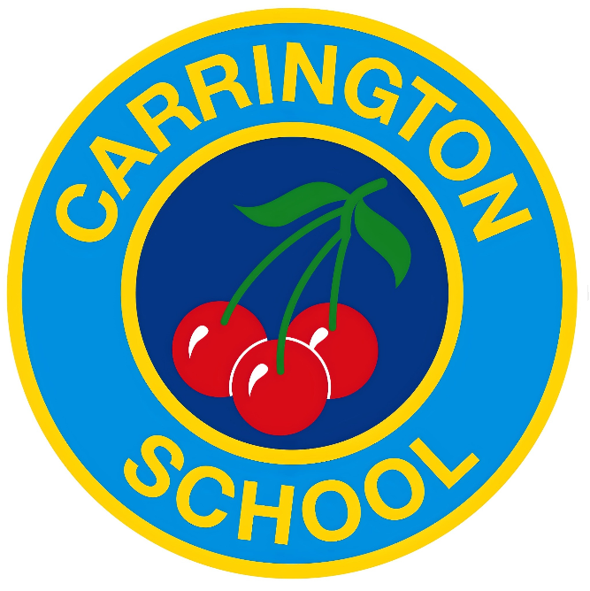

Contents

1. Introduction
2. Subject Intent
3. Aims and Outcomes
4.Teaching and Learning
5.Curriculum Overview
6. Cross Curricular Links
7.Assessment and Recording
8.Resources
9.Roles and Responsibilities
10.Inclusion
11.Links to other Policies
12. Monitoring and Review

Introduction

Music is a powerful, universal form of communication that can fulfil an instinctive human need for self-expression. A high quality music education should engage and inspire pupils to develop a love of music and their talent as musicians, and so increase their self-confidence, creativity and sense of achievement. It transcends different cultures, abilities and generations and can change the way pupils think, feel and act. As pupils progress, they should develop a critical engagement with music, allowing them to compose, and to listen with discrimination whilst stimulating responses on an emotional and intellectual level. Music can be a lifelong source of pleasure and an education for life.

Subject Intent
Some of the first communication we give and receive in life is through music. It ignites all areas of child development and skills including intellectual, social-emotional, motor, language, and overall literacy and helps the body and the mind work together. ​

Music is a pastime, distraction, hobby and art form and is necessary for shaping our cultural identity. Cultures everywhere take pride in and relish the opportunity to gather and enjoy music together. ​

Music and happiness go hand in hand all over the world.

Aims and Outcomes

All pupils shall:

• Listen to and appraise a variety of genres and styles of music.
• explore how sounds are made, and how music is produced by a variety of instruments;
• develop imagination and creativity;
• build a sense of pulse and rhythm;
• understand a range of musical vocabulary;
• develop the interrelated skills of composition, improvisation, performance and appreciation;
• enjoy a wide range of songs and sing in tune;
• develop positive attitudes and to experience success and satisfaction in music.

• Undertake a balanced programme of activities.
• Work individually, in groups or as a whole class.
• Make appropriate use of ICT to create and record music.
• Make use of outside agencies, peripatetic teachers, music concerts etc.
• Make use of audio/visual material.
• Record findings in a variety of ways.
• Learn one musical instrument (glockenspiels) in whole class ensemble lessons.
• Perform to wider audiences of parents, local community and other schools at end of year productions, assemblies, and Christmas shows.
• Have the opportunity to access music clubs - Choir and Rocksteady.

Teaching and Learning

At Carrington Infant School we encourage children to participate in a variety of musical experiences through which we aim to build up the confidence of all children. Singing is an integral part of our school life and our teaching focuses on developing the children's ability to sing in tune, developing their expression and ability to listen to others, particularly during weekly singing assemblies. Pupils’ understanding of music will be developed through activities which bring together the requirements of performing, composing, listening and appraising. Children are taught to make music together with tuned and un-tuned instruments and to compose pieces. They are also taught to sing and play in time controlling the sound and pace. They are taught different ways to represent sounds graphically and symbolically.

Our school uses the Charanga scheme (from Durham Music Service) as the basis for its curriculum planning. This scheme has an integrated, practical, exploratory and child led approach to musical learning. The learning within this scheme is based on:

• Listening and Appraising,
• Musical Activities (including Creating and Exploring)
• Singing and Performing.

There are opportunities for children of all abilities to develop their skills and knowledge in each unit and the progression planned into the scheme of work means that the children are increasingly challenged as they move through the school. All musical learning in the scheme is based around the Interrelated Dimensions of Music; pulse, rhythm, pitch, tempo, dynamics, timbre, texture, structure and notation.

Curriculum Overview

Music is taught from Reception to Year 2 using the Charanga Music online platform.

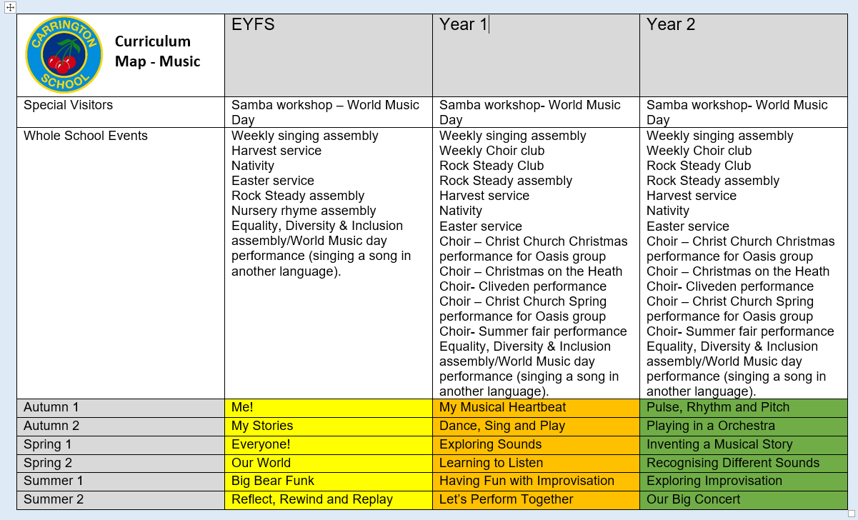

Early Years Foundation Stage (EYFS)

Expressive Arts and Design

"The development of children’s artistic and cultural awareness supports their imagination and creativity. It is important that children have regular opportunities to engage with the arts, enabling them to explore and play with a wide range of media and materials. The quality and variety of what children see, hear and participate in is crucial for developing their understanding, self-expression, vocabulary and ability to communicate through the arts. The frequency, repetition and depth of their experiences are fundamental to their progress in interpreting and appreciating what they hear, respond to and observe."
(Statutory Framework for the Early Years Foundation Stage, 2023)

ELG: Being Imaginative and Expressive
- Sing a range of well-known nursery rhymes and songs; Perform songs, rhymes, poems and stories with others, and – when appropriate – try to move in time with music.
(Statutory Framework for the Early Years Foundation Stage, 2023)

KS1

Music is a foundation subject as part of the National Curriculum 2014.
The objectives for KS1 are for children to

- Use their voices expressively and creatively by singing and speaking chants and rhymes
- Play tuned and untuned instruments musically
- Listen with concentration and understanding to a range of high quality live and recorded music
- Experiment with, create, select and combine sounds using inter related dimensions of music

Continuous Provision in Year 1
In Year 1, children access a continuous provision approach which supports and extends their musical learning. Through this provision, pupils engage in planned musical play projects that are carefully linked to the National Curriculum for Music. These projects are designed and facilitated by teachers to provide opportunities for children to explore, experiment, and apply their musical understanding in creative ways. The key skills and knowledge introduced during discrete music lessons are revisited, reinforced, and developed through these play-based activities across the week, ensuring that learning is embedded and made meaningful within the children’s wider classroom experiences

Cross Curricular Links

English - Teachers skillfully model vocabulary in Music lessons through discussion and modelling of the interrelated dimensions of music. New vocabulary is revisited in future lessons and Children are able to develop their oracy skills as they appraise and articulate how particular pieces of music make them feel.
Maths - Counting songs foster a child’s mathematical ability whilst incorporating maths concepts and vocabulary. Children will develop and support their maths learning through sequences, patterns, composition, fractions and time.
Science - Children develop and support their Science learning through recognising sequences and patterns. Children explore changing pitch, volume and tempo as they listen to and play a variety of musical instruments. How sound travels and use of vibration is explored through playing different instruments in different ways. Focus on listening skills and how the ear works is key to appreciating music and recognising similarities and differences in styles of music.
Computing –Children's music making is supported by the use of computing technology to record performances, compositions and for the purpose of assessment.
Art - Art and Music are both forms of art used to portray an emotion and create a reaction. Art uses colours, light, darkness, shapes, and music uses instruments, key changes, sounds, lyrics, and more to do the same.
Design and Technology -Children talk about what different instruments are made from and how you can play them.
History - Children explore the context of historical songs. They find out about composers from the past and listen to and appraise music from different time periods.
Geography - Children listen to and appraise music from different countries and cultures and increase their knowledge of where music fits in the world.
Physical Education (PE) - Children match movement and actions to music when dancing.

Assessment

Assessment is an integral part of teaching and enables staff to meet the needs of all pupils. Teachers use a range of methods in order to monitor and assess pupil progress, including:

Early Years Foundation Stage

Children’s progress is constantly reviewed through ongoing observations of the children’s music ability during structured music sessions and during their free play. Photos and videos are recorded on Tapestry and in classroom learning journeys. Children’s next steps are identified and planned for through a mixture of child initiated and adult led activities using Development Matters.

Key Stage 1

Children demonstrate their ability in music in a variety of different ways. Teachers will assess children’s work in music by making informal judgements as they observe them during lessons and through play (Year 1). Video recordings are made of live musical performances for the children to use as self-assessment. On completion of a piece of work, the teacher will assess the work and give oral feedback. Pupils are encouraged to make judgements about how they can improve their own work. Individual class teachers will keep samples of children’s work in music for their own evidence.

A focus group of children are monitored and assessed using PITA (Point in Time Assessments) using the progression documents that match our bespoke curriculum. This is a reliable way to track and progress and attainment in Music and our foundation subjects.

Resources

The following resources are available to aid the teaching of music at Carrington Infant School;
• Charanga music scheme
• Sparkyard online platform
• sound system, computer and projector in the hall
• a range of musical resources on CD which includes classical, popular and cultural music
• a selection of un-tuned percussion instruments
• tuned instruments – glockenspiels and recorders

Roles and Responsibilities

The coordination and planning of the music curriculum are the responsibility of the subject leader, who also:
• keeps colleagues and school governors informed about developments in music and provides a strategic lead and direction for the subject;
• discusses progress with the Head Teacher and evaluates strengths and weaknesses in music;
• reviews the success of the Charanga music scheme and reviews evidence of children’s work;
• arranges external music providers to provide workshops for the school.
Inclusion

Activities should be carefully planned by the class teacher and be adapted where appropriate for children with SEN and equally the more able and Gifted and Talented children. All resources/materials have been reviewed with equal opportunities in mind, e.g. race, gender, ethnicity. Learning experiences in music will be available to every child, regardless of race, gender, class or ability. Pupils will be encouraged to value social and cultural diversity through musical experiences. They will listen to, and participate in, a variety of experiences in a positive and constructive role.
We recognise that in all classes, children have a wide range of musical ability, and so we seek to provide suitable learning opportunities for all children by matching the challenge of the task to the ability of the child. We achieve this in a variety of ways:
• setting tasks which are open-ended and can have a variety of responses;
• setting tasks of increasing difficulty;
• grouping children by ability and setting different tasks for each group; • grouping children in mixed ability groups;
• providing resources of different complexity, depending on the ability of the child;
• using classroom assistants to support the work of individuals or groups of children.

Links to other Policies
Assessment
Behaviour
SEND

Monitoring and Review

The class teachers, Music co-ordinator, Head teacher and the Music Governor will monitor the approaches detailed in this policy, in line with school policy and assessment procedures.

